photo

The fight against Drug abuse in Cameroon is a collaborative effort between the institution for fight against drug abuse and rehabilitation COFADARE and the Cameroon Government and other Non-Governmental Organization.
Cameroon Branch Board

The board has received a mandatary mission to prevent Drug and suppress Drugs addiction in Cameroon in director collaboration with the Cameroon government.
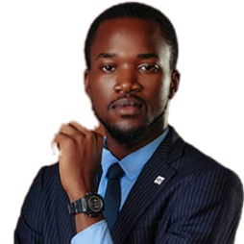
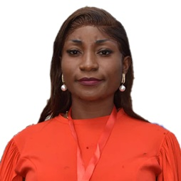
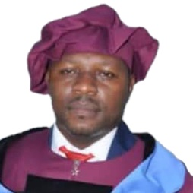
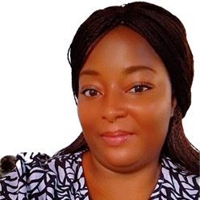
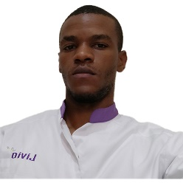
Badefoma Gisele Audrey Epse Assale
COMMUNICATION OFFICER

M.TCHOFFO TCHAPNGA Curlis Nitario
PUBLIC RELATION OFFICER

Mme AKAMBA FRANCK Virginia
SECRETARY GENERAL
Dr TOUOMOU NYONGHA PIERRE PHILIPPE
FEILD AND PROGRAM COORDINATOR
Dr TATSI SOP Isidore
FINANCIAL.
Branch Director

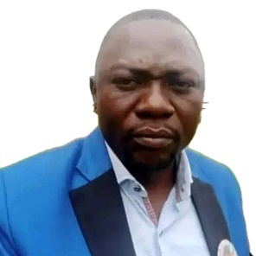
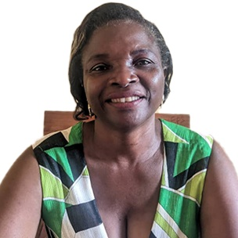
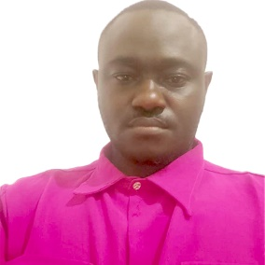
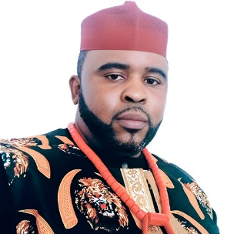

M.NGWANA Yanic Zozong
PEACE, JUSTICS AND LEGAL RIGHT PROTECTION OFFICER

NJINYWAM NGWANIBAH JULIUS
RISK AND HUMANITERIAN MANAGER

Mme.HASSAN DASSE
MEDICAL AND PSYCHIATRIC DIRECTOR

Mr. Fon Francis Suyi
COORDINATOR AND TRAINING MANAGER

PROJET MANAGER

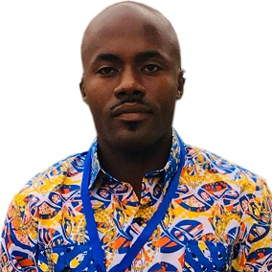
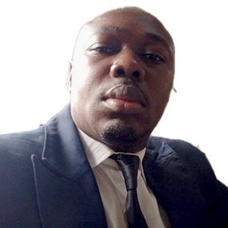
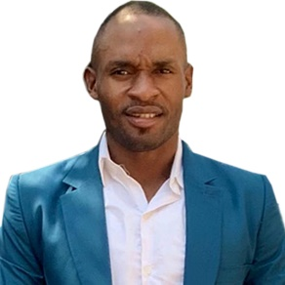
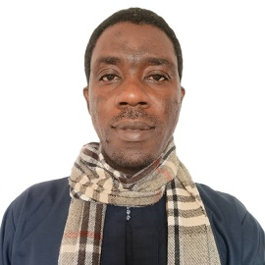
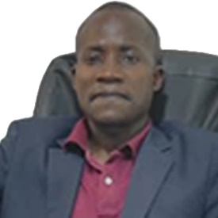

M.TOGUE NANA DIPANADA Franklin
TECHNICAL ADVISOR NEB

Dr. KOUAMOU WETI Boris Brice
HEAD OF CLINICAL AND MEDICAL ASSISTANCE

M.ONDOUA RENE Charle
CIVIL DEFENSE AND SECURITY OPERATION OFFICER

OKAH NJOUH Eric Cinqclear
SPORT MANAGER

Dr. OVAMBE MBARGA Guy-Bertrand
HEAD OF PSYCOLOGICAL SUPPORT

Mme.HASSAN DASSE
PSYCHOLOGICAL AND PSYCO-SOCIAL OFFICER

